File permissions in Linux

Project description
This project demonstrates the management and modification of file and directory permissions in Linux using the ls -la and chmod commands. It explores interpreting permission strings, updating access levels for files and directories, and managing hidden files. These actions ensure that only the appropriate users or groups have access to specific resources, enhancing security and collaboration in a shared environment.
Check file and directory details
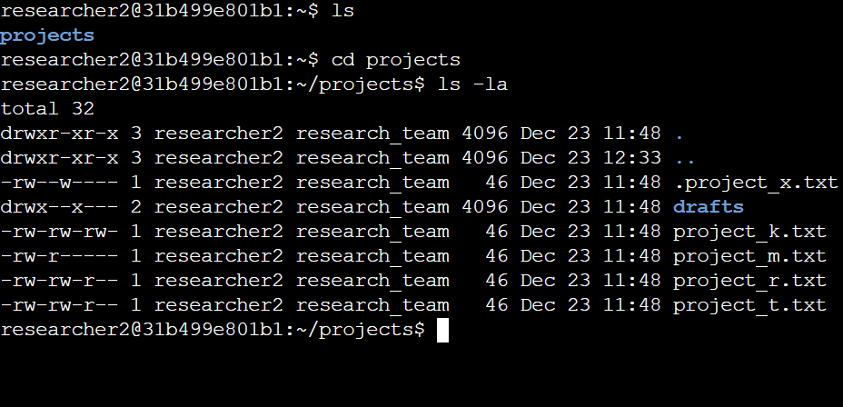
Describe the permissions string
The 10-character string representing the permissions for a file in Linux can be broken down and described as follows. I'll use the permissions for project_x.txt from your screenshot as an example: -rw--w----.

Description of -rw--w----

-: The first character indicates the type of file. A dash (-) means it's a regular file. Other possible characters include:

  - d for a directory
  - l for a symbolic link
  - b for a block device
  - c for a character device

rw-: The next three characters represent the permissions for the owner (in this case, researcher2):

  - r (read): The owner can read the file.
  - w (write): The owner can write to the file.
  - - (no execute): The owner cannot execute the file.

-w-: The next three characters represent the permissions for the group (research_team):

  - - (no read): Members of the group cannot read the file.
  - w (write): Members of the group can write to the file.
  - - (no execute): Members of the group cannot execute the file.

---: The last three characters represent the permissions for others (users outside the owner and group):

  - - (no read): Others cannot read the file.
  - - (no write): Others cannot write to the file.
  - - (no execute): Others cannot execute the file.

Summary
This string -rw--w---- means the file project_x.txt is a regular file where:
- The owner has read and write permissions.
- The group has write-only permission.
- Others have no permissions.

Change file permissions
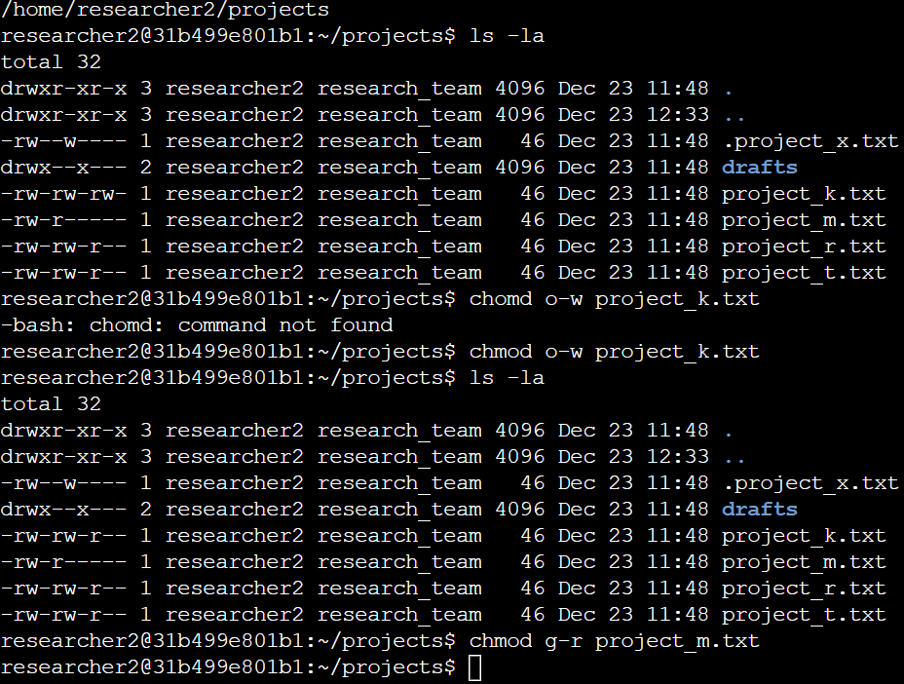
Change file permissions on a hidden file
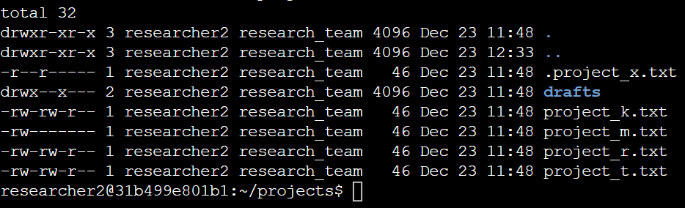

Change directory permissions
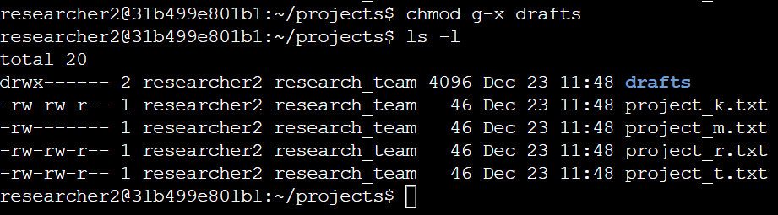
Summary
This activity highlighted the use of Linux commands to manage file and directory permissions effectively. By using ls -la to analyze permission settings and chmod to modify them, access control was customized for various files and directories. These actions ensure secure and efficient file management in a shared Linux environment, which is a critical skill for IT professionals.

